SERVICE AGREEMENT - AdGrades

This Service Agreement ("Agreement") is formally entered into on this 1st day of December, 2025, by and between:
- AdGrades, a marketing agency maintaining its principal place of business atK-Hoskoppal,Hassan,Karnataka, hereinafter referred to as the "Agency"; and
- Madhu Medicals, a medical retail service provider maintaining its principal place of business at Nelmangala, hereinafter referred to as the "Client".
The Agency and the Client shall hereinafter be collectively referred to as the "Parties" and individually as a "Party".

1. DEFINITIONS
1.1 "Services" shall mean the marketing, development, and performance services meticulously described in Section 2 (Scope of Services / Exhibit A) of this Agreement.
1.2 "Commencement Date" shall be defined as 1 December 2025.
1.3 "Term" shall denote the initial two (2) month period, commencing on the Commencement Date and concluding on 31 January 2026 (inclusive), unless prematurely terminated in strict accordance with the provisions of this Agreement.
2. SCOPE OF SERVICES (EXHIBIT A)
The Agency formally covenants and agrees to furnish the following services to the Client during the Term:
2.1 Social Media Management
- Execution of a comprehensive account audit and development of a strategic brief (covering platforms: Facebook, Instagram, X, and others as mutually specified).
- Production of a content calendar: comprising a minimum of twelve (12) static posts and four (4) short-form videos/reels per calendar month.
- Provision of professional caption writing, foundational graphic design, and a structured hashtag strategy.
- Execution of community management duties: responding promptly to comments and direct messages during the Agency's stipulated working hours.
- Delivery of a detailed monthly performance report and actionable insights.
2.2 Website Development
- Creation of design mockups (for the homepage and all essential inner pages) for Client review, followed by the commencement of development upon formal approval.
- Development of a fully responsive website (comprising up to X pages, with the exact number to be specified) inclusive of a functional contact form and foundational Search Engine Optimization (SEO) setup.
- Integration of a Content Management System (CMS) (WordPress or other selected CMS) and provision of one (1) hour of necessary training for Client personnel.
- Deployment to a staging environment, comprehensive testing, and final launch on the Client’s designated hosting/domain (or a temporary Agency-hosted staging environment if necessitated).
- Inclusion of fifteen (15) calendar days of post-launch bug-fix support.
2.3 Funnel Marketing
- Development of a marketing funnel blueprint, specifically delineating the awareness, consideration, and conversion stages.
- Creation of dedicated landing page(s) for campaigns, implementation of lead capture forms, and establishment of simple automation sequences (email and/or WhatsApp flows).
- Setup of the lead capture mechanism and formal handover to the Client’s Customer Relationship Management (CRM) system (if applicable).
- Formulation of an A/B testing plan for the primary landing page(s).
2.4 Performance Marketing
- Development, setup, and continuous management of advertising campaigns for Meta and/or Google Ads platforms.
- Creation of ad creative assets (comprising ad copies and three (3) variations per campaign) and provision of fundamental reporting.
- Execution of weekly monitoring and optimization activities (including adjustments to bids, audience targeting, and placements).
- Delivery of a consolidated monthly performance report, encompassing comprehensive insights and recommendations for subsequent steps.
2.5 Deliverables & Key Performance Indicators (KPI)
- Specific Deliverables and the corresponding timelines for each service shall be formally documented in an onboarding plan, to be provided to the Client within five (5) business days following the Commencement Date.
- Mutually agreed-upon high-level KPIs for the two-month Term shall include, but not be limited to: Social reach/impressions, Website visits, Leads generated, and Cost per lead (all of which shall be precisely specified in the onboarding plan). The Parties shall formally measure performance against these established KPIs during the review meeting at the conclusion of the Term.
3. TERM
3.1 This Agreement shall officially commence on 1 December 2025 and shall continue in force for a duration of two (2) months, terminating on 31 January 2026, unless it is earlier terminated in accordance with the provisions stipulated herein.
3.2 Within seven (7) calendar days following the Term end date, authorized representatives of the Agency and the Client shall convene (either virtually or in-person) to conduct a formal performance review, agree upon the future scope of work, and negotiate any necessary amendments to the fees or the engagement model.
4. FEES & PAYMENT TERMS (EXHIBIT B)
4.1 Quoted Fee: The Agency’s original quoted monthly fee was established at INR 30,000.
4.2 Negotiated Fee: The Parties hereby agree to a discounted fee of INR 25,000 per month for the entirety of the initial two-month Term.
4.3 Total for Term: The total fee payable for the Term shall be INR 25,000.
4.4 Payment Schedule:
a) The fee for Month 1, amounting to INR 25,000, is due and payable prior to the Commencement Date (i.e., on or before 1 December 2025).
4.5 Payment Method: Payment shall be executed via UPI or Bank Transfer to AdGrades' official account (with detailed account information to be formally provided).
4.6 Late Payment: Any payments not fully received within three (3) calendar days of the stipulated due date shall be subject to a late fee of INR 500 per diem until the outstanding amount is remitted. The Agency reserves the right to suspend the provision of Services after seven (7) days of continuous non-payment.
4.7 All stated fees are exclusive of applicable taxes. Any and all requisite taxes, duties, or levies shall be charged additionally and shall be the sole responsibility of the Client for payment.
5. SERVICE RULES
5.1 Revisions: A maximum of two (2) rounds of revisions are comprehensively included per deliverable. Any and all additional revisions requested shall be billed at the Agency’s prevailing hourly rate.
5.2 Client Response Time: The Client formally agrees to furnish all necessary approvals, assets, and feedback within forty-eight (48) hours of the Agency’s request to prevent delays in the project timeline.
5.3 Working Hours: The Agency’s standard working hours are designated as Monday through Saturday, 10:00 AM – 7:00 PM Indian Standard Time (IST).
5.4 Approval Flow: Final and definitive approval for all creative content and material rests solely with the Client prior to any public publishing or dissemination.
6. COMMUNICATION & REPORTING
6.1 Primary Channel: The primary channel for communication shall be WhatsApp. Secondary channels include Email and Slack (if mutually requested and agreed upon).
6.2 Points of Contact:
- Agency: Mr. Likitesh Gowda: +91 80736 98913
- Client: Mr. Madhu : ‪+91 90366 85043
6.3 Reporting Frequency: The Client shall receive weekly performance snapshots (via WhatsApp or Email) and a comprehensive, detailed monthly report at the close of each calendar month.
7. CONFIDENTIALITY
7.1 Each Party hereby covenants to maintain the strict confidentiality of all proprietary and non-public information disclosed by the other Party and shall utilise such information exclusively for the purpose of fulfilling the obligations set forth in this Agreement.
7.2 These confidentiality obligations shall survive the termination of this Agreement for a period of three (3) years.
8. TERMINATION
8.1 Either Party retains the right to terminate this Agreement by providing the other Party with fifteen (15) days’ prior written notice.
8.2 Should the Client elect to terminate the Agreement mid-month, the fees for the current month shall remain due and payable and shall be strictly non-refundable.
8.3 Subsequent to termination and the full settlement of all outstanding invoices, the Agency shall formally hand over all work-in-progress and completed deliverables to the Client.
9. LIMITATION OF LIABILITY
9.1 The Agency shall not be held liable for any indirect, incidental, consequential, or special damages whatsoever.
9.2 The Agency’s maximum aggregate liability for any and all claims arising out of or directly related to this Agreement shall in no event exceed the total fee paid by the Client for the most recently completed service month.
10. OWNERSHIP OF WORK
10.1 Upon the full and final payment of all sums due under the terms of this Agreement, the Client shall acquire full ownership of the final deliverables produced specifically for the Client. Source files (including design files, code repository links, etc.) may be transferred as mutually agreed upon and documented in the onboarding plan.
10.2 The Agency shall retain the irrevocable right to showcase the completed work in its professional portfolio and marketing materials, provided that the Client’s confidential information is not disclosed without the Client's explicit prior written permission.
11. WARRANTIES & DISCLAIMERS
11.1 The Agency warrants that the Services shall be executed with reasonable professional skill and care.
11.2 Except for the warranties expressly provided herein, the Agency hereby disclaims all other warranties, whether express or implied.
12. FORCE MAJEURE
Neither Party shall be held liable for any delay or failure to perform its obligations hereunder if such delay or failure is caused by events demonstrably beyond its reasonable control (such as Acts of God, labour strikes, governmental action, etc.). The period for performance shall be equitably extended for the duration of any such delay.
13. DISPUTE RESOLUTION & JURISDICTION
13.1 The Parties shall endeavour, in good faith, to resolve any disputes arising amicably through mutual discussion.
13.2 Should a dispute remain unresolved within a period of thirty (30) days, the matter shall be subject to the exclusive jurisdiction of the courts situated in Bangalore, Karnataka, India.
14. ENTIRE AGREEMENT
This Agreement (including all referenced Exhibits) constitutes the entire and exclusive agreement between the Parties concerning its subject matter. Any and all amendments hereto must be documented in writing and formally executed by the authorized signatories of both Parties.
15. MISCELLANEOUS
15.1 Notices: All formal notices must be in writing and delivered to the addresses specified in the header of this Agreement or as subsequently updated in writing.
15.2 Assignment: Neither Party may assign its rights or delegate its obligations under this Agreement without the prior written consent of the other Party, with the sole exception of assignment to a successor in interest.
15.3 Severability: Should any provision of this Agreement be deemed unenforceable by a court of competent jurisdiction, the remaining provisions shall nonetheless remain in full force and effect.
16. ONBOARDING & TIMELINES
16.1 The Agency shall deliver a comprehensive onboarding plan within five (5) business days from 1 December 2025, providing meticulous details on milestones, page counts, required Client assets, and target launch dates.
16.2 Illustrative Website Development Milestones:
- Day 0–5: Comprehensive requirement gathering and sitemap finalisation.
- Day 6–15: Design mockup creation and formal Client approvals.
- Day 16–35: Development execution and internal Quality Assurance (QA).
- Day 36–45: Staging environment reviews and final launch (contingent upon timely Client approvals).
(The precise, final timelines shall be meticulously captured within the onboarding plan.)

17. PERFORMANCE REVIEW AFTER TERM
17.1 Within seven (7) calendar days following 31 January 2026, the Parties shall formally convene to:
a) Review the actual performance against the Key Performance Indicators (KPIs) agreed upon in the onboarding plan.
b) Determine and agree upon the scope of work and associated fee for any future engagement.
c) Execute a new formal agreement or formally amend this existing Agreement, provided both Parties are in mutual assent.

IN WITNESS WHEREOF, the Parties have duly caused this Agreement to be executed by their respective authorized representatives on the date first written above.

For AdGrades
Name: Chandan B Krishna
Designation: CEO
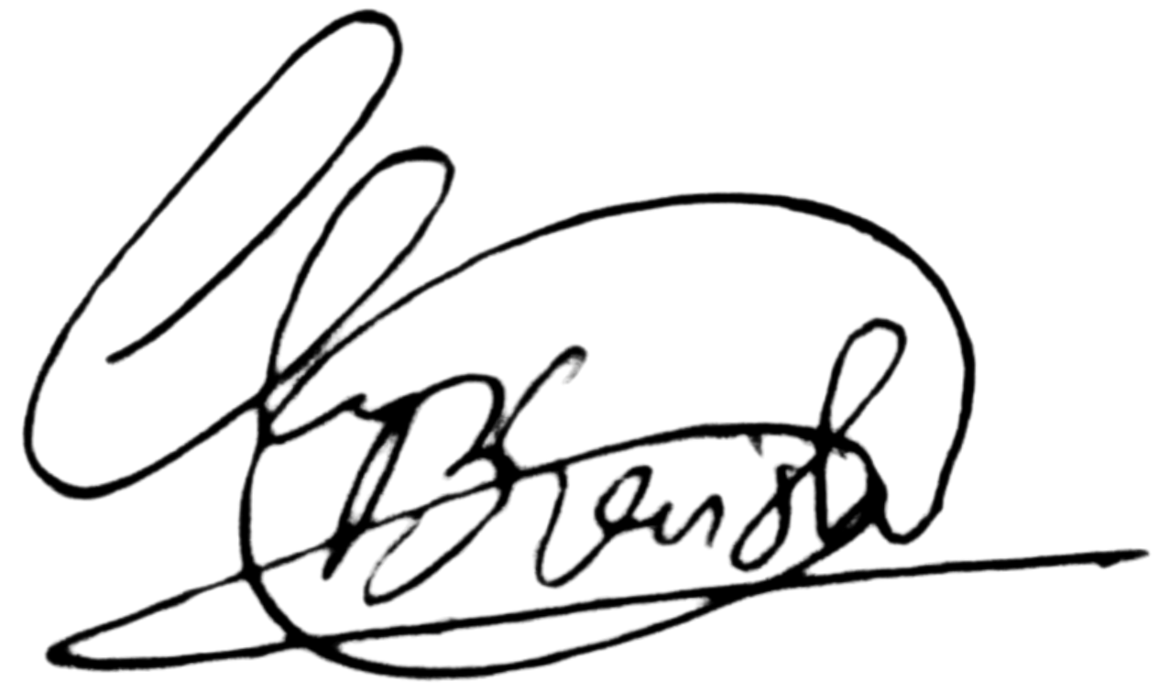
Signature:
Date: 1 December 2025

For Madhu Medicals
Name: __________________________________________________ (Authorized-Representative)
Designation: ______________________________________

Signature: ______________________________________
Date: __________________________________________________

EXHIBIT A — DETAILED SCOPE (to attach the onboarding plan)
EXHIBIT B — FEES & PAYMENT SCHEDULE (as per Section 4)

